File Hosting System (FHS)

Requirements Document

Zawartość

Introduction 2

High level requirements 2

System architecture 3

# Introduction

This document describes a requirements for new system called File Hosting System (FHS). The main objective of FHS is storing user uploaded files.

# Mockups

### Main Page

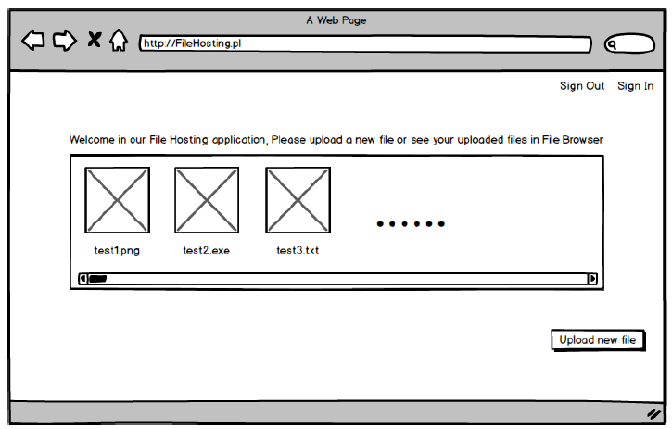

### Login Page

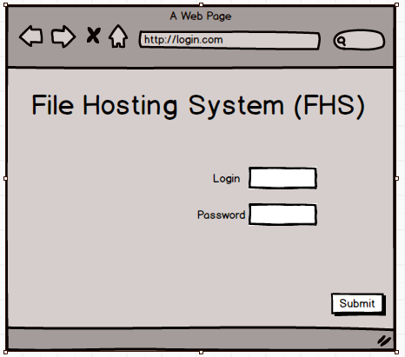

# High level requirements

* User should be able to manage these files - manage I understand as upload new file, download the file from application, remove file from hosting
* Unregistered and not logged users cannot upload the file
* Application can contain any kind of file, regardless the file extension
* Any new user can be registered
* Application doesn't allow to load files from "C:\Program Files" space
* User can see only files uploaded by himself, cannot see others files

# System architecture

SERVER

REST Service – Web Api

Http request

CLIENT

ASP.NET MVC 4